**LADYBUG BLINKY-BOT INSTRUCTABLE**

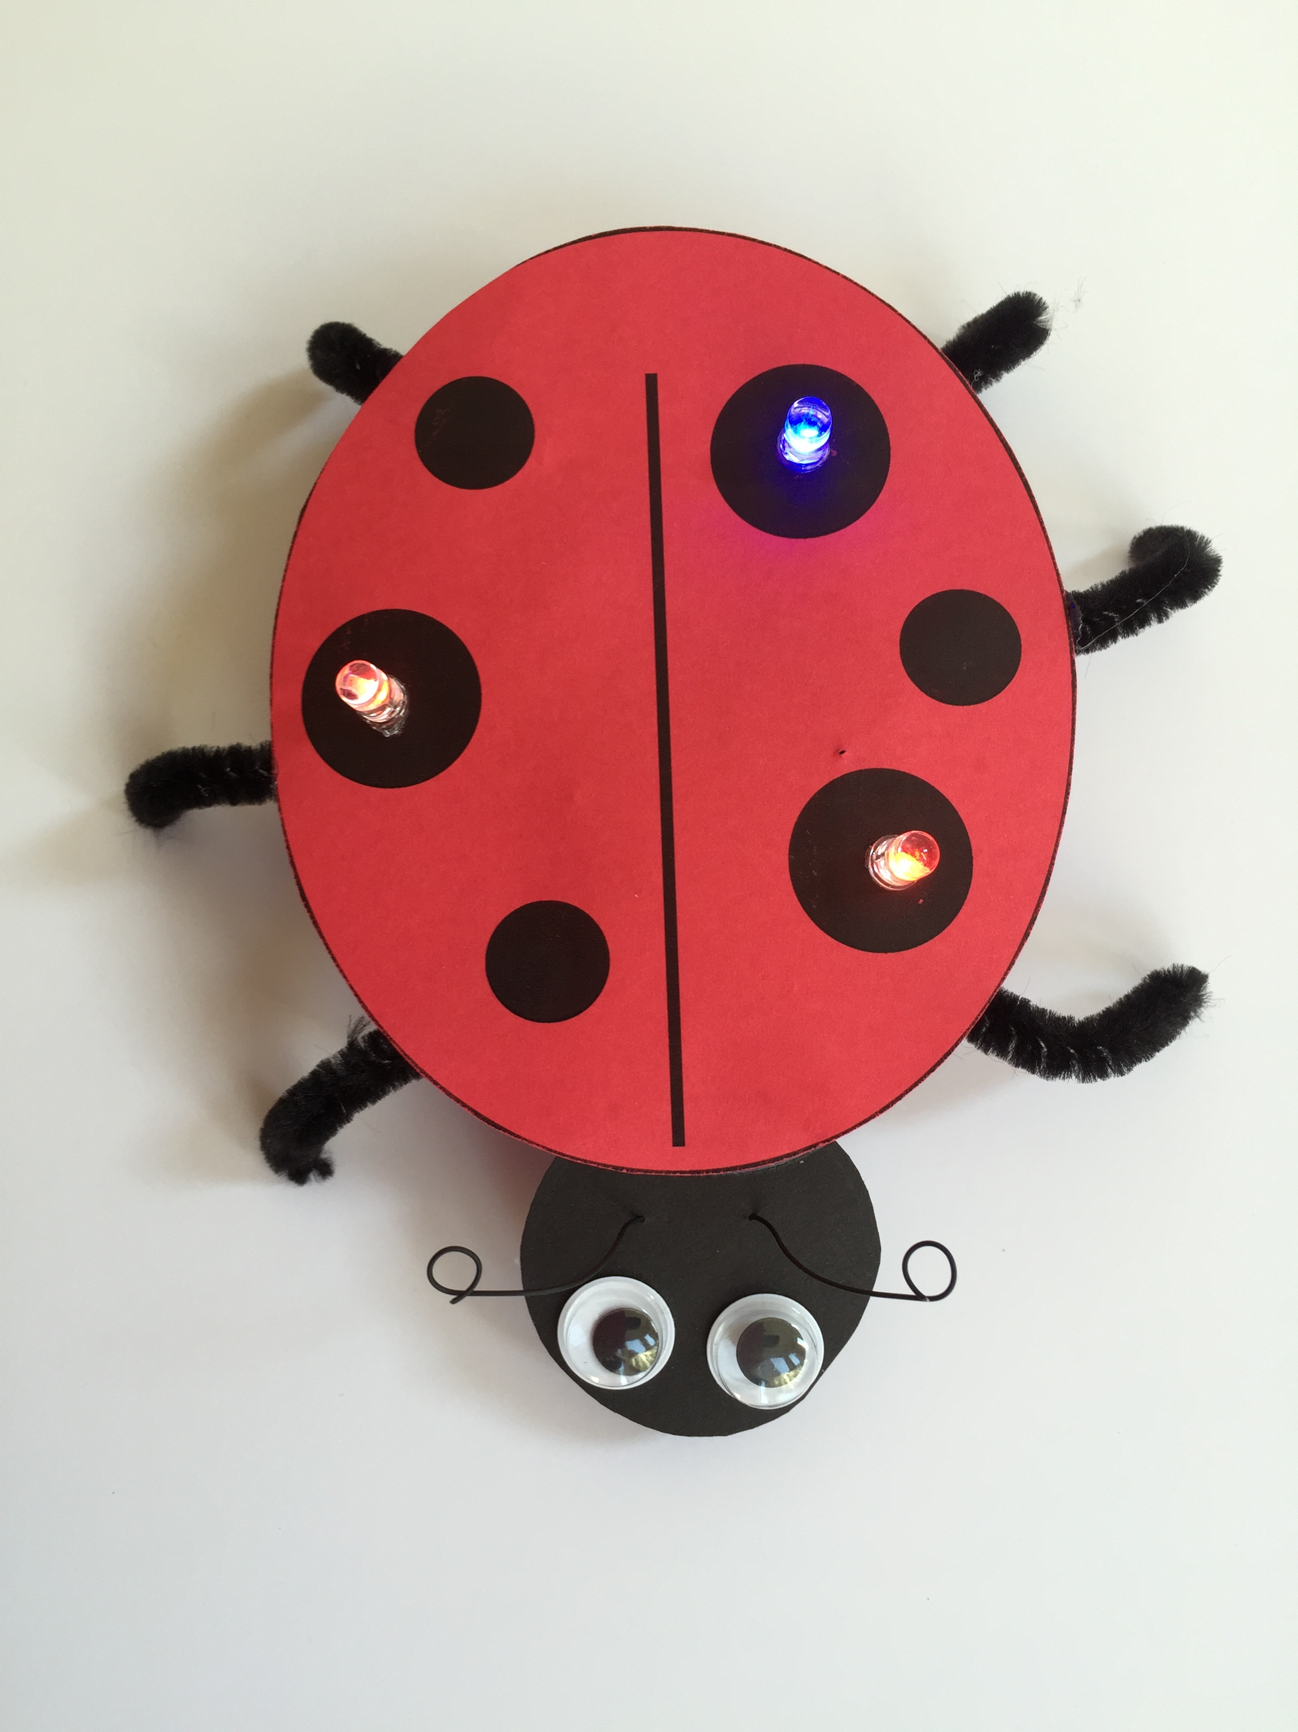

**WESTERN CANADIAN**

**ROBOTICS SOCIETY**

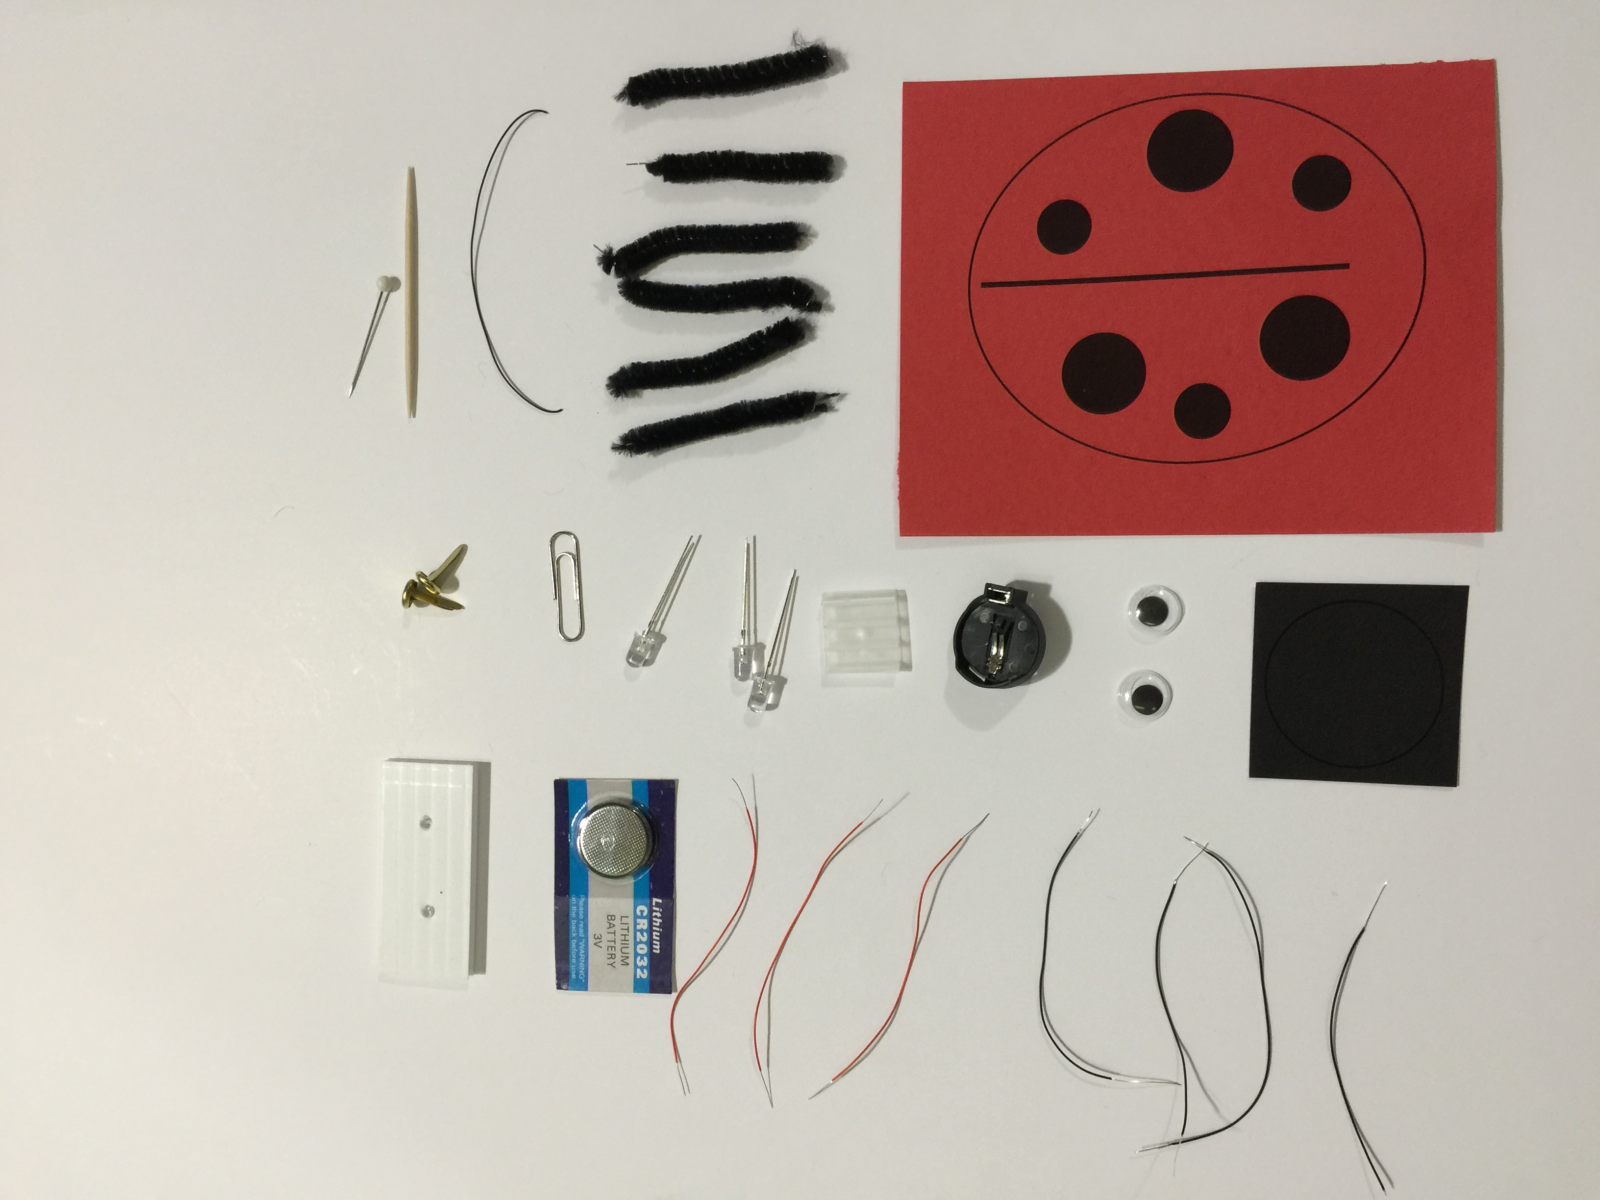

Get the supplies:

1 – ladybug body printed on red cardstock

1 – ladybug head printed on black cardstock

1 – 12 inch black pipe cleaner cut into 6 equal pieces

2 – googly eyes

1 – 3 inch piece of black AWG 30 wire (not stripped)

4 – 3 inch pieces of black AWG 30 wire (stripped 1/4 - 3/8 inch on both ends)

3 – 3 inch pieces of red AWG 30 wire (stripped 1/4 - 3/8 inch on both ends)

1 – coin cell battery holder

1 – 3V coin cell battery (CR 2032)

3 – fast blink multi-colored LEDs

1 – paper clip

2 – brads (~1/2 inch)

1 – 1 inch x 2 inch corrugated cardboard or plastic piece, with 2 holes punched 1 inch apart

1 – 3/4 x3/4 inch square corrugated cardboard or plastic piece

1 – toothpick

1 – straight pin

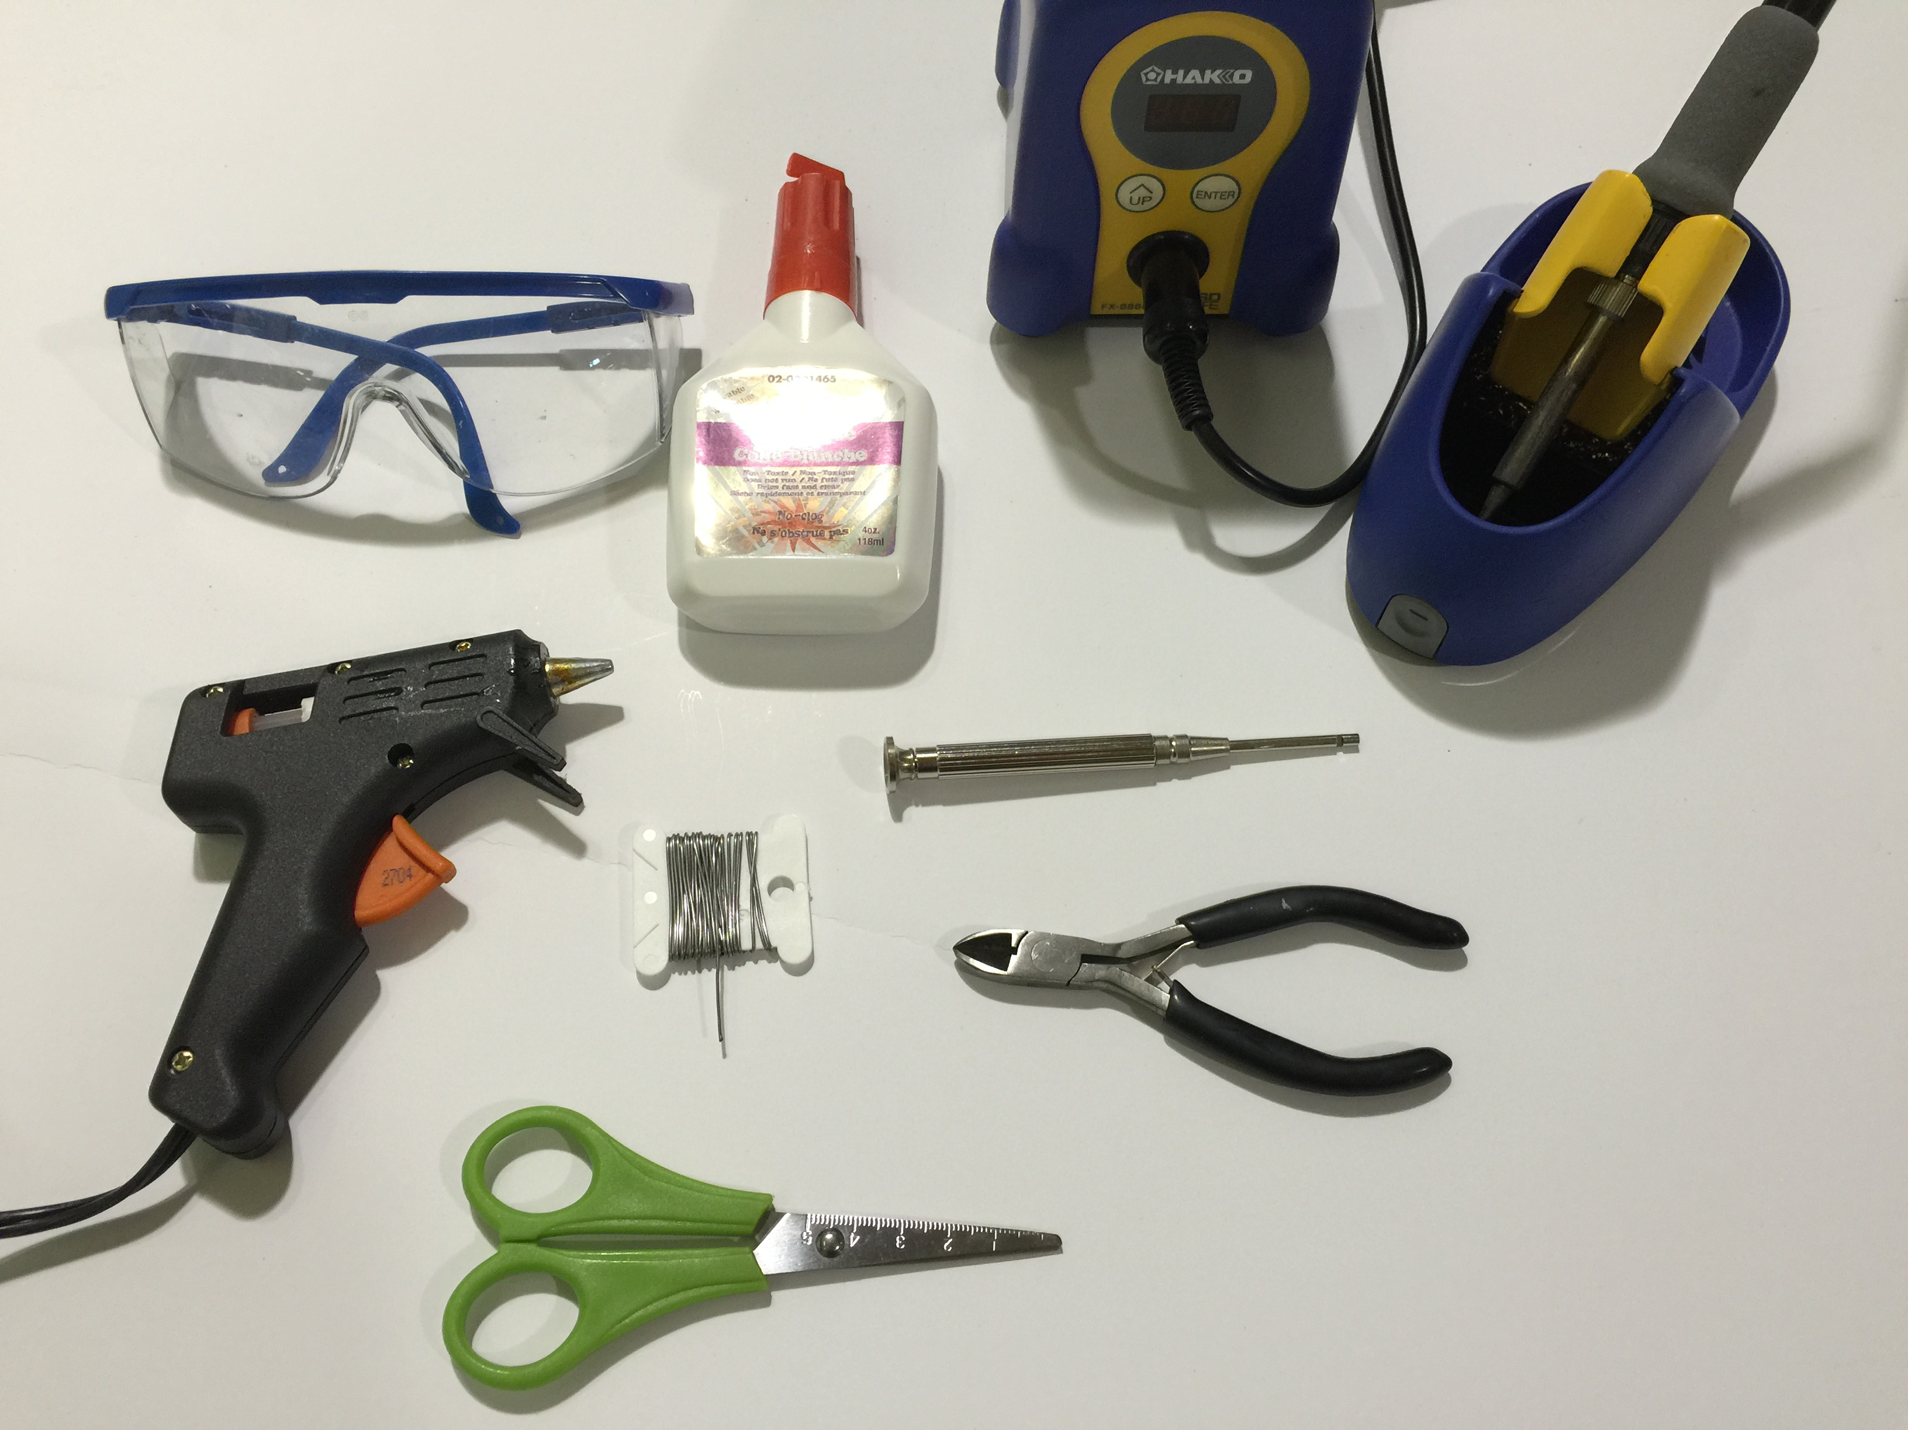

Assemble the tools:

safety glasses

hot glue gun

white glue or glue stick

scissors

wire cutters

wire wrap tool

soldering iron

solder

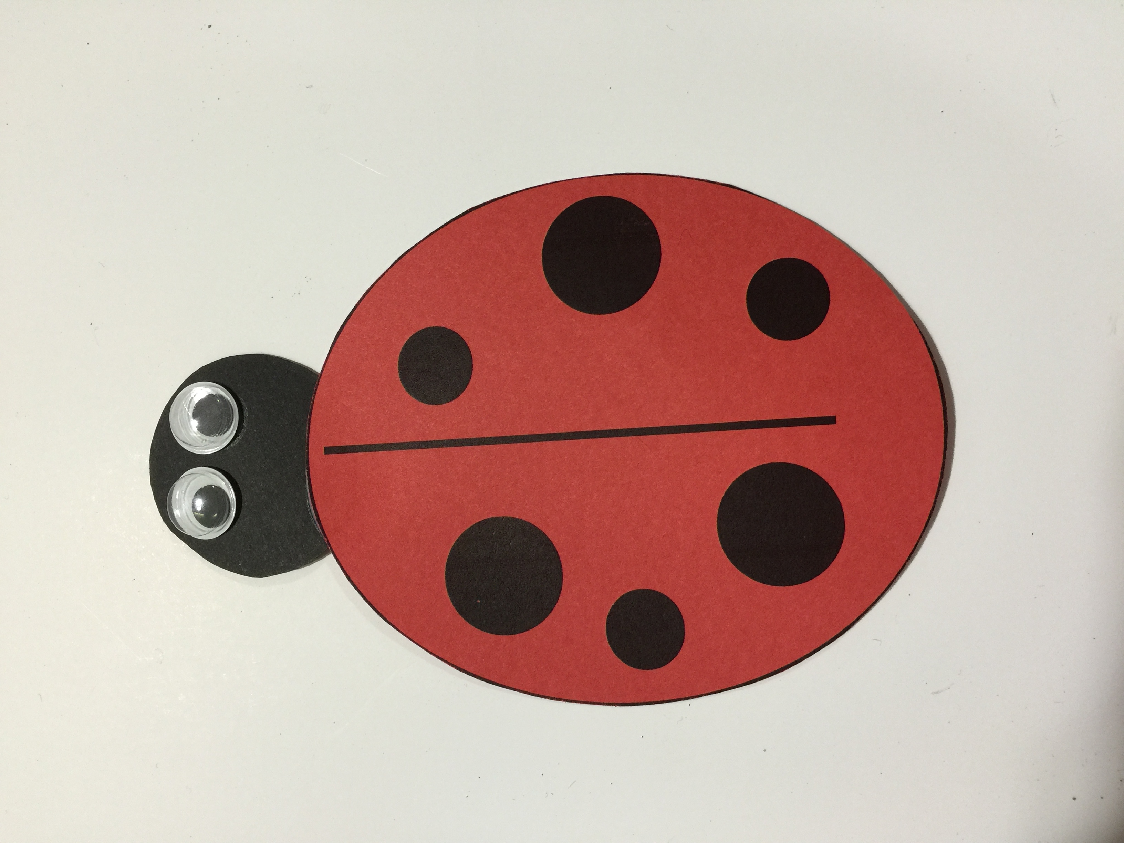

1. Cut out body.
2. Cut out the head. Glue into place by placing the head slightly under the body.
3. Glue on the googly eyes.

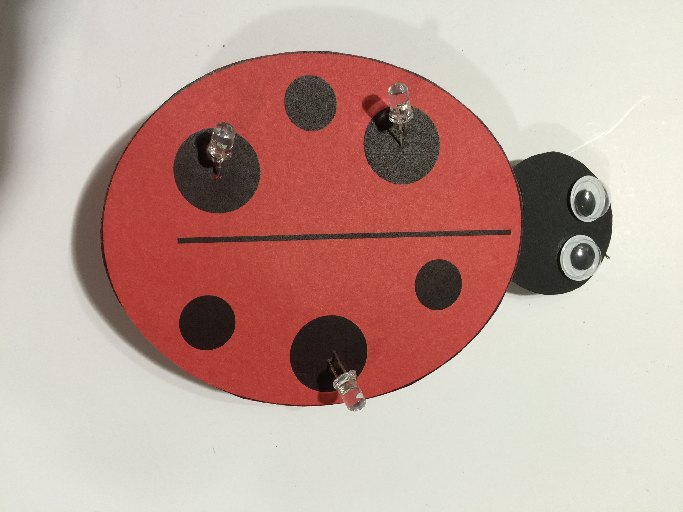

1. Using a straight pin, punch two holes for the LEDs in each of the three large dots.
2. Install the LEDs through the holes. Place a small dab of glue under each LED.

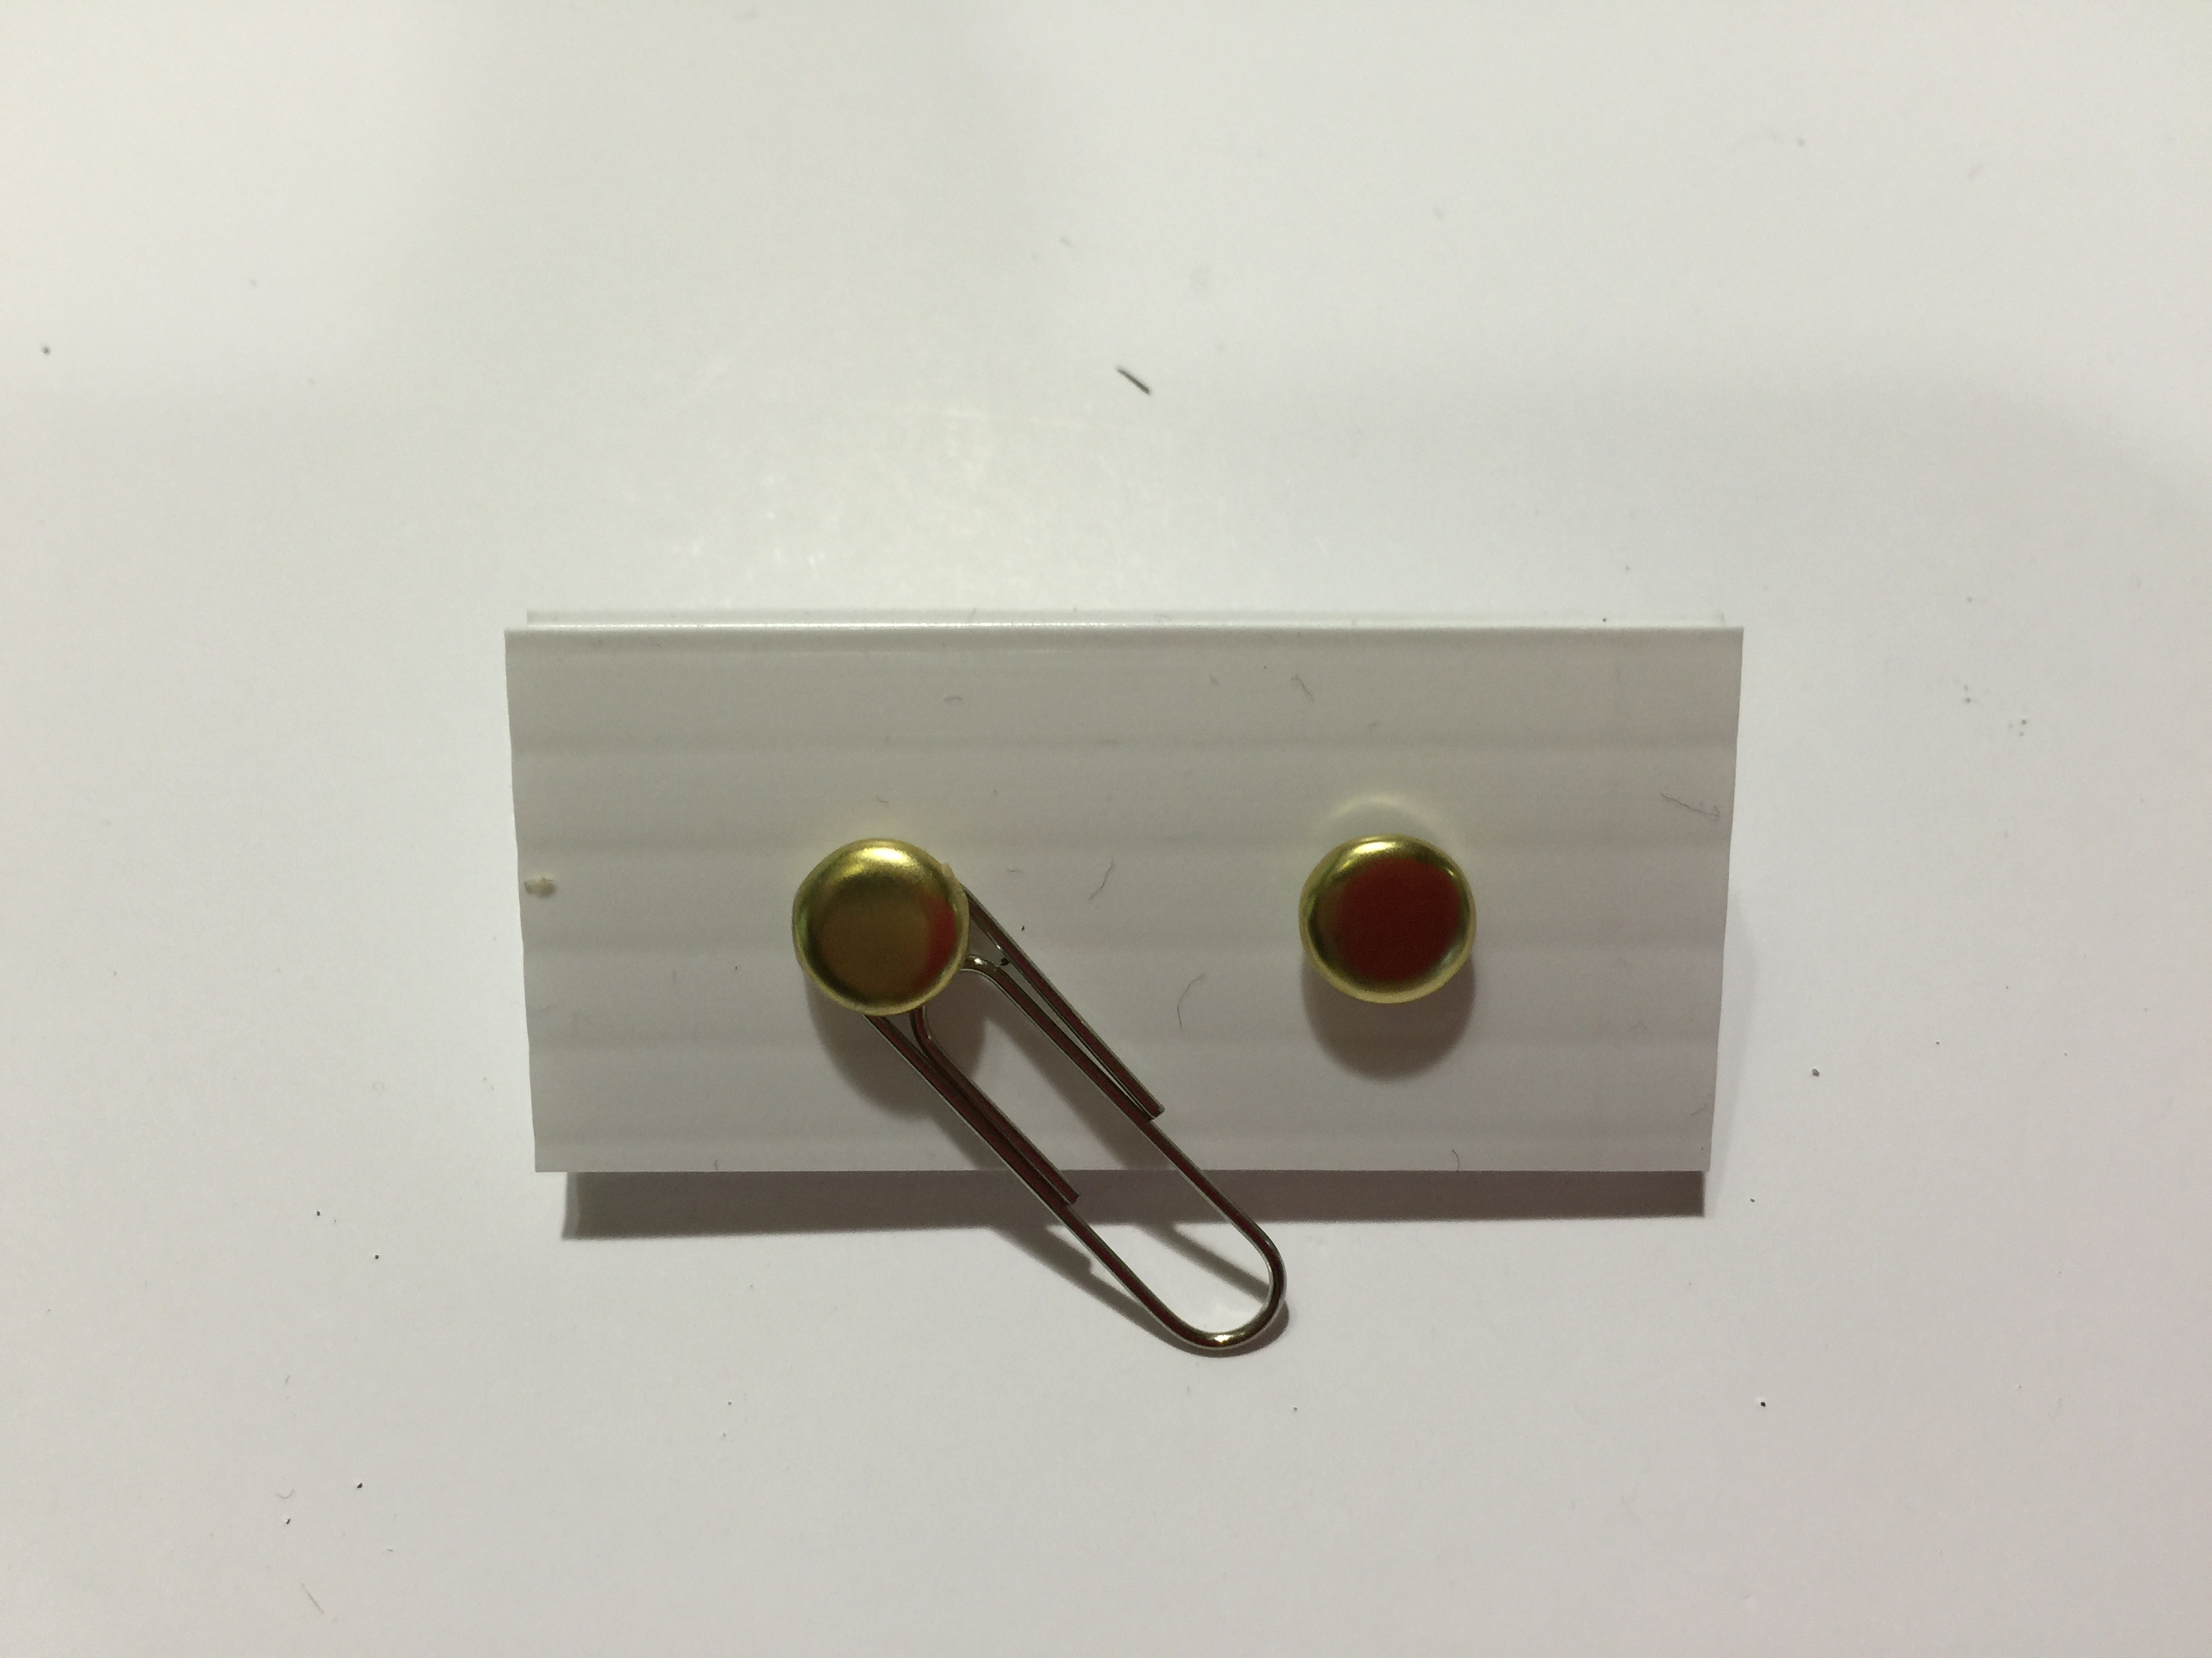

1. Assemble the switch from the corrugated rectangle, the two brads, and the paperclip according to the above picture.

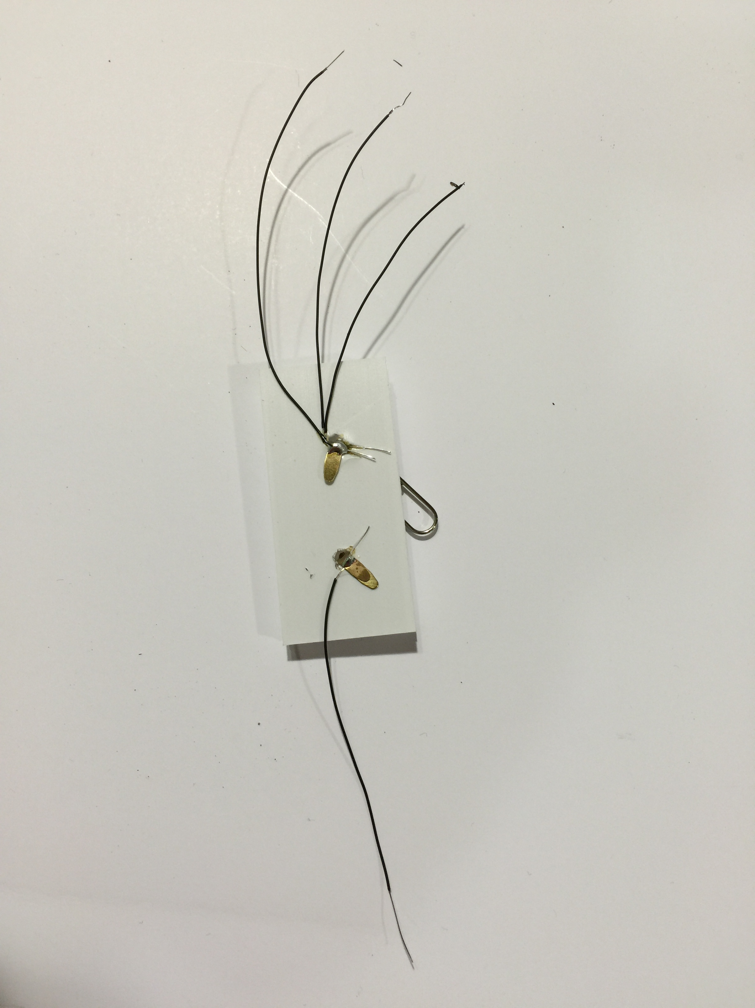

1. On the bottom of the switch, attach three black wires to one brad and one black wire to other brad. Solder in place.

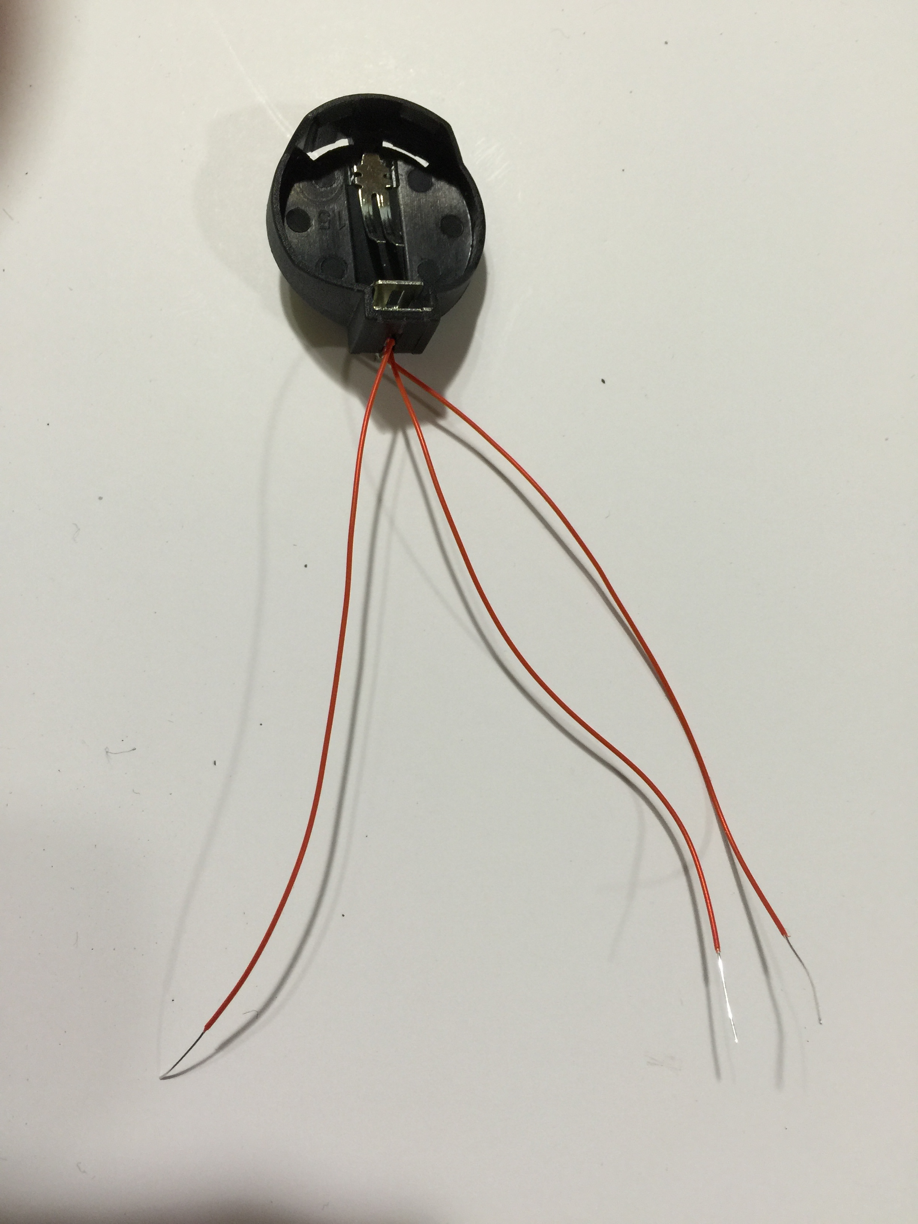

1. Using the wire wrap tool, attach three red wires to positive (larger) end of battery holder. Solder in place.

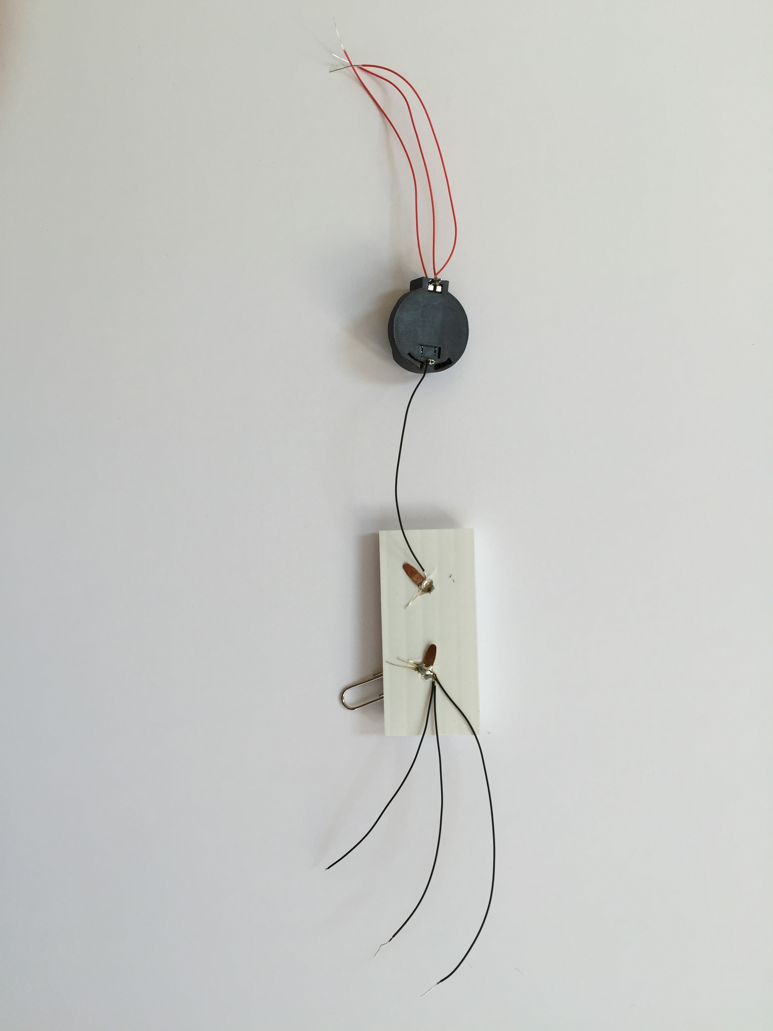

1. Using the wire wrap tool, attach the single black wire from the switch to the negative (smaller) end of the battery holder. Solder in place.

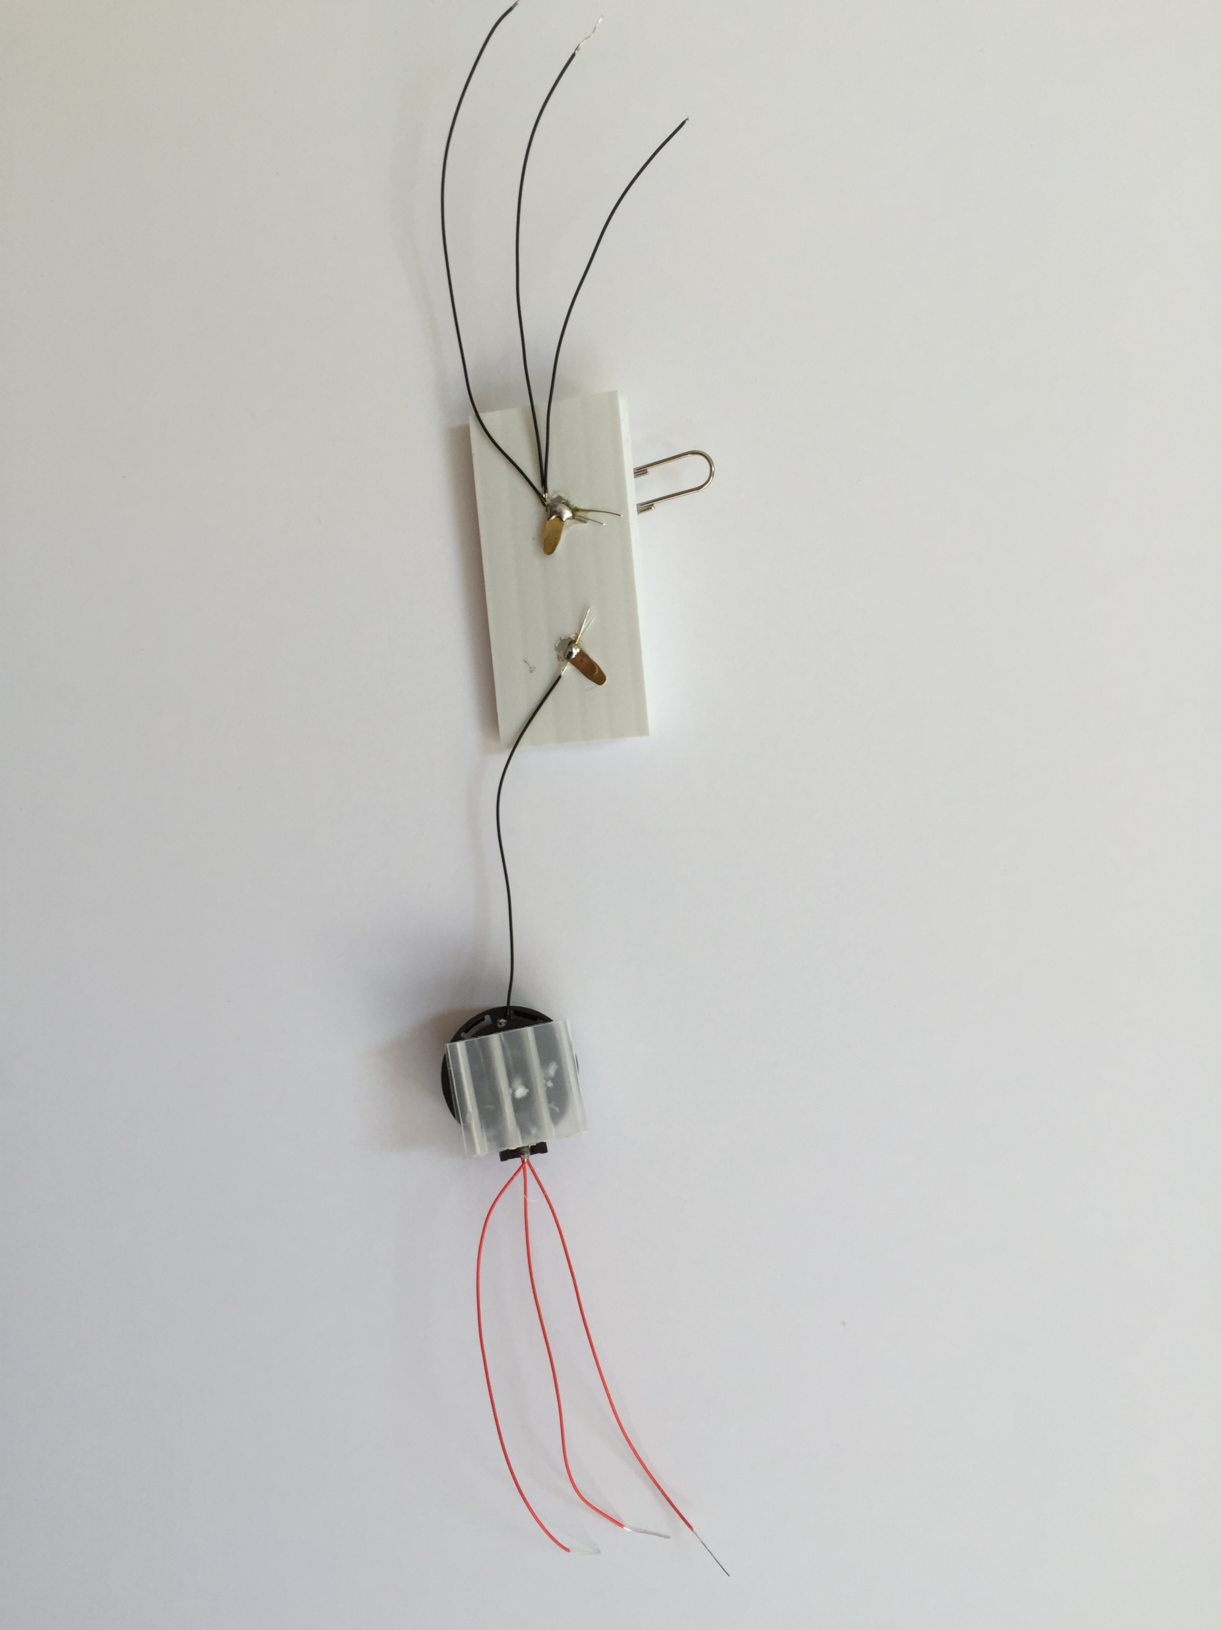

1. Hot glue the small corrugated square to the back of the battery holder.

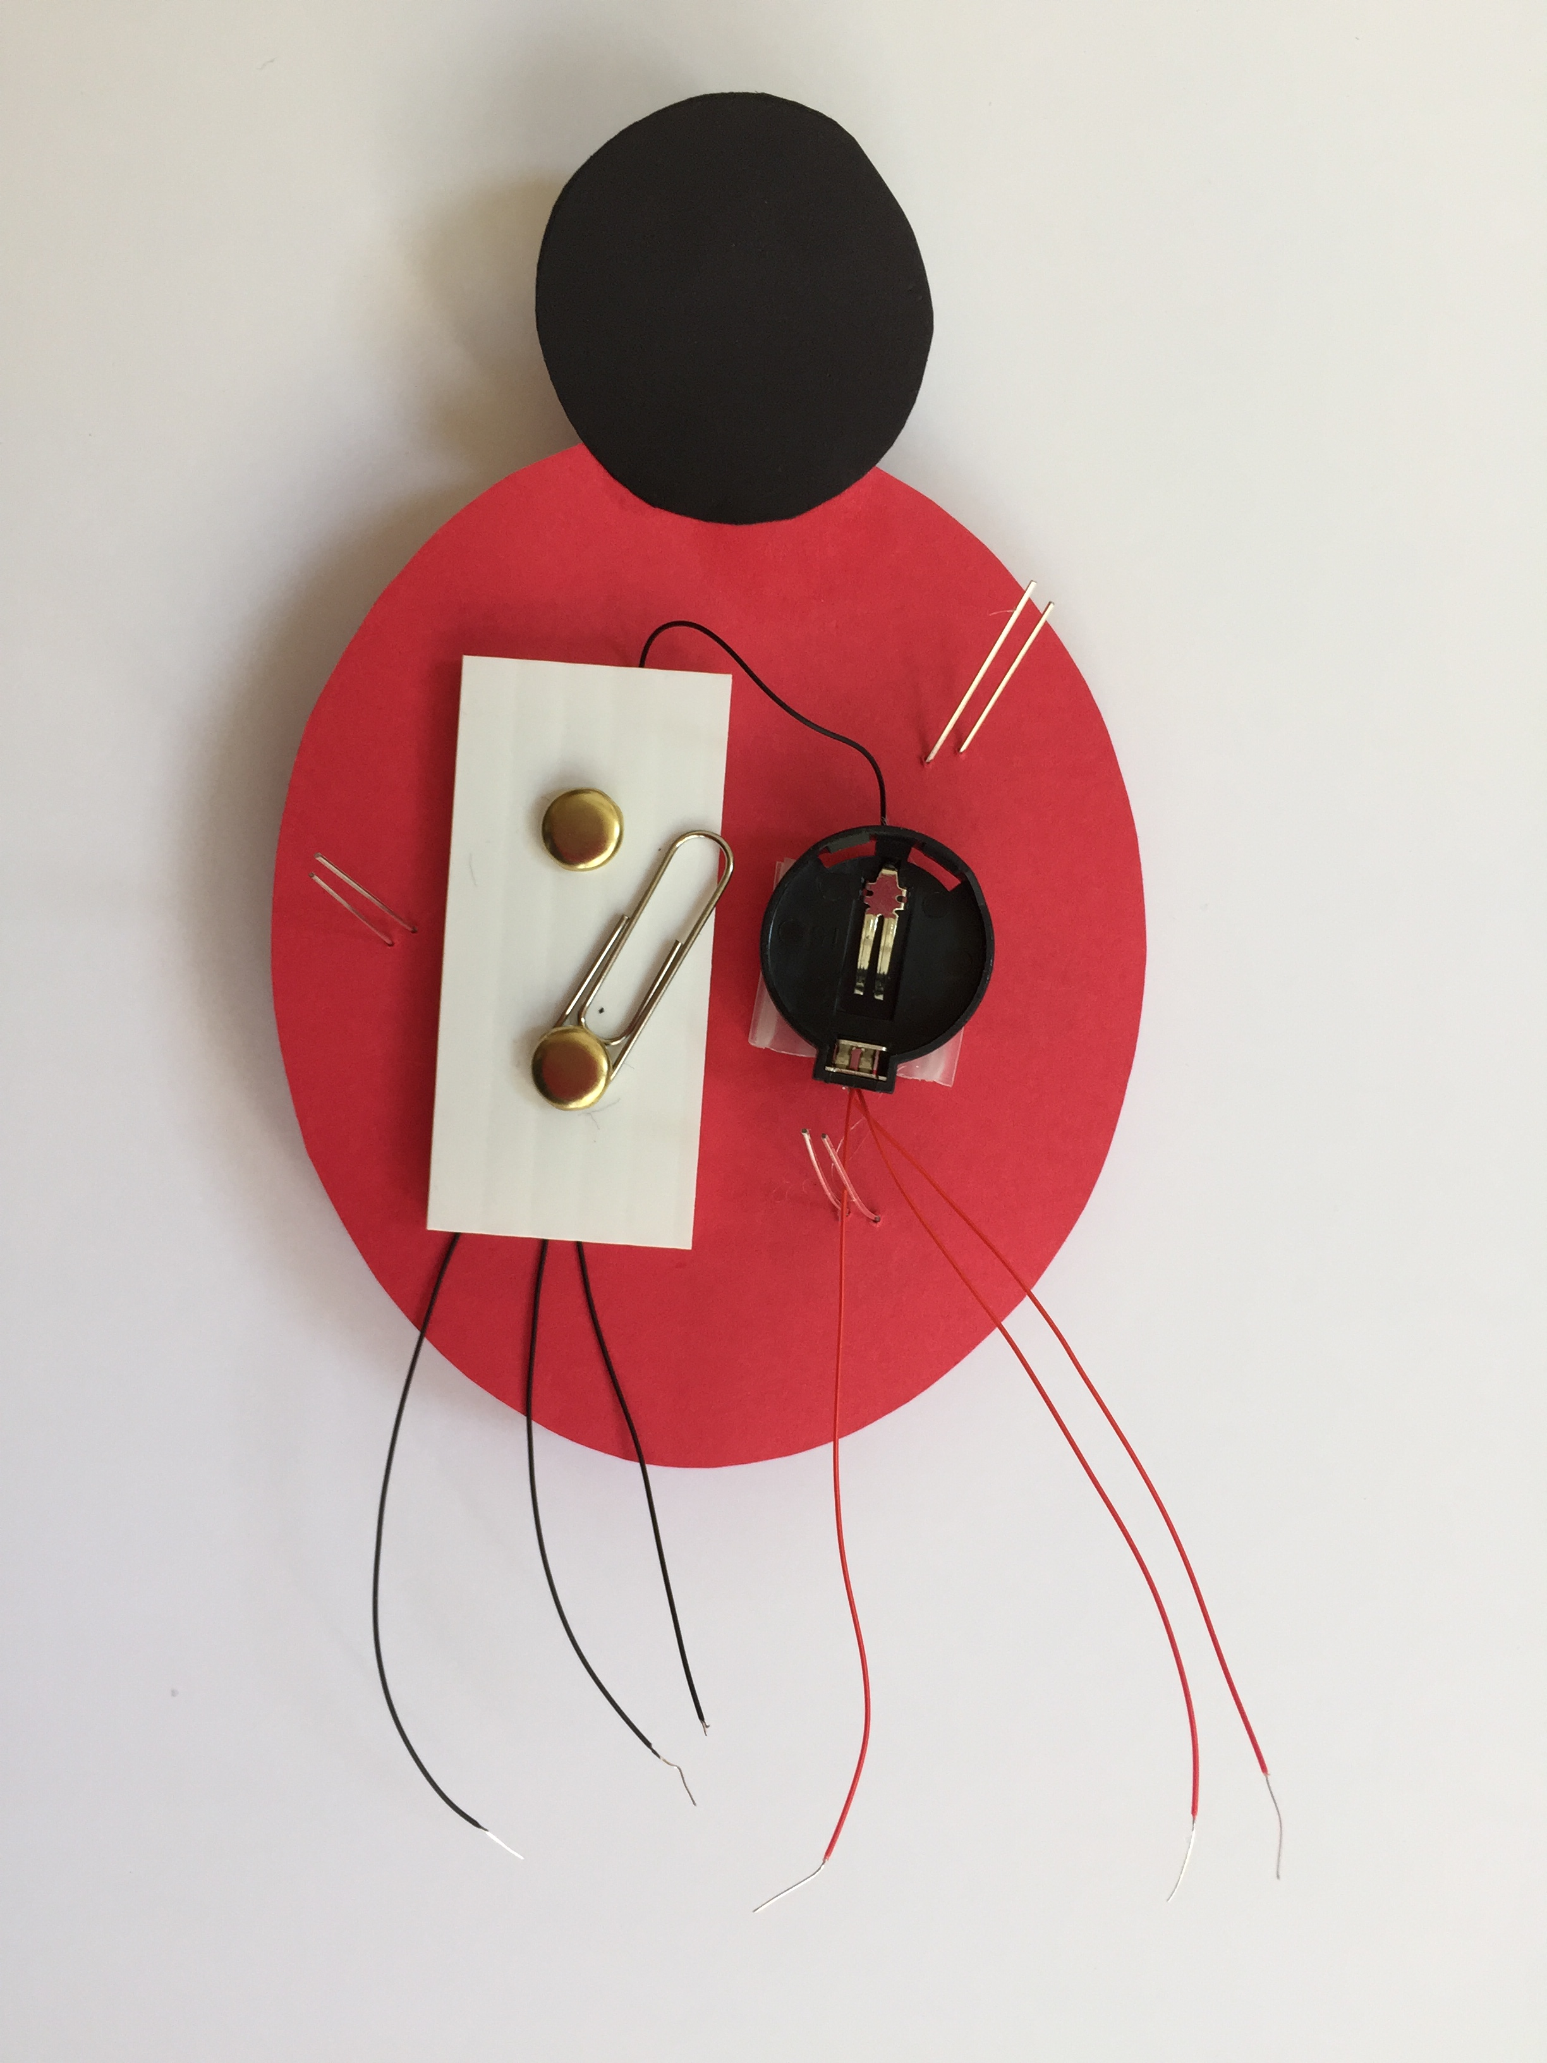

1. Hot glue the switch in the center of the ladybug body, making sure that the black wires will reach the LEDs.
2. Hot glue the battery holder in the center of the ladybug body, making sure that the red wires will reach the LEDs.

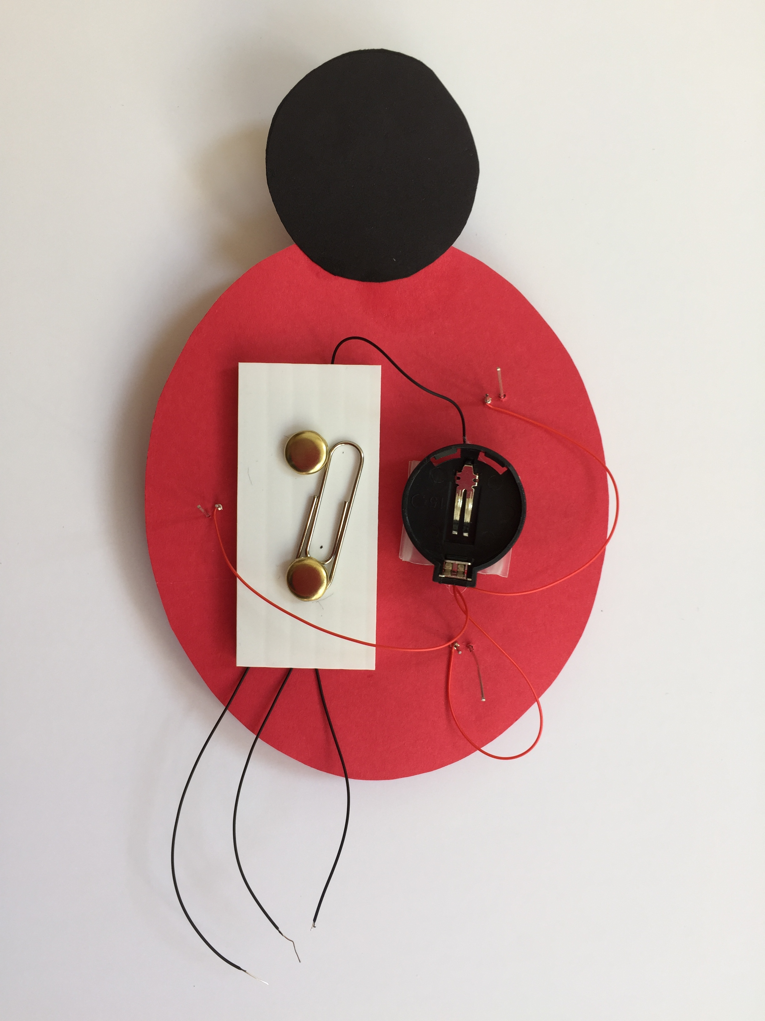

1. After putting on safety glasses, trim the three longer leads of the LEDs to ~1/4 inch.
2. Using the wire wrap tool, attach the three red wires to each of the cut LED leads. Solder in place.

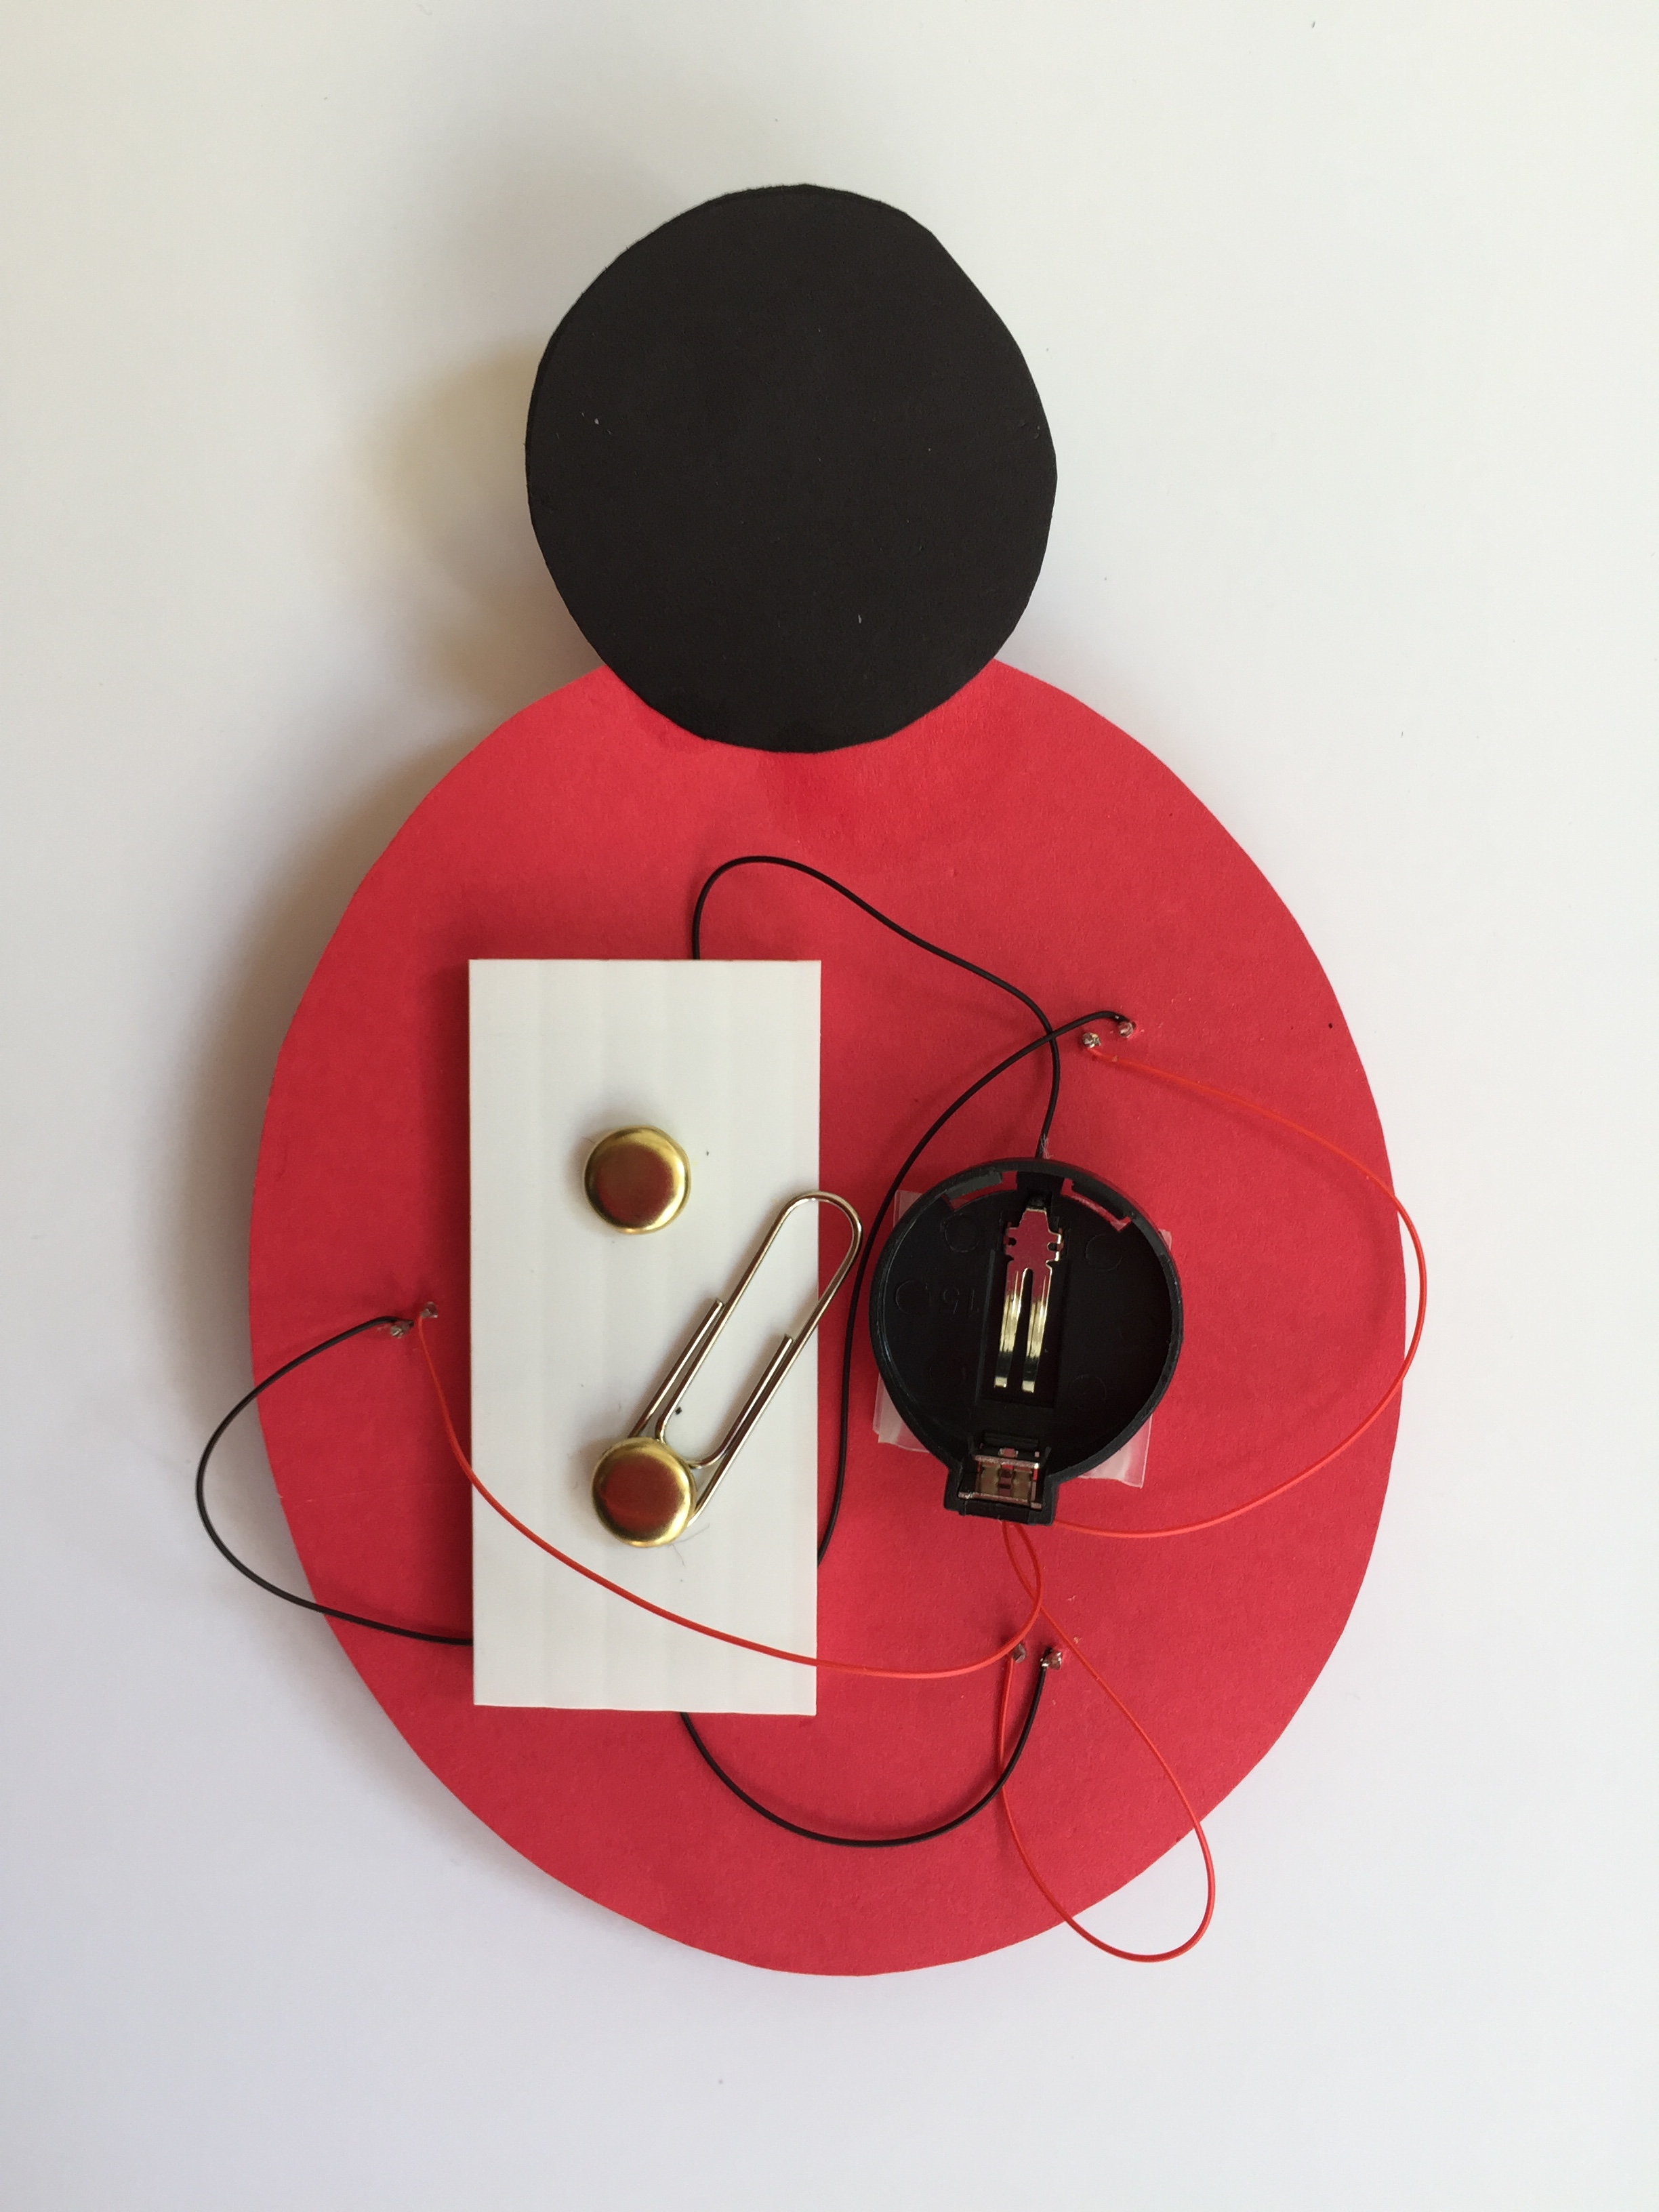

1. After putting on safety glasses, trim the three remaining LED leads to ~1/4 inch.
2. Using the wire wrap tool, attach the three black wires to each of the remaining leads. Solder in place.
3. If needed, put on safety glasses and trim the LED leads again.

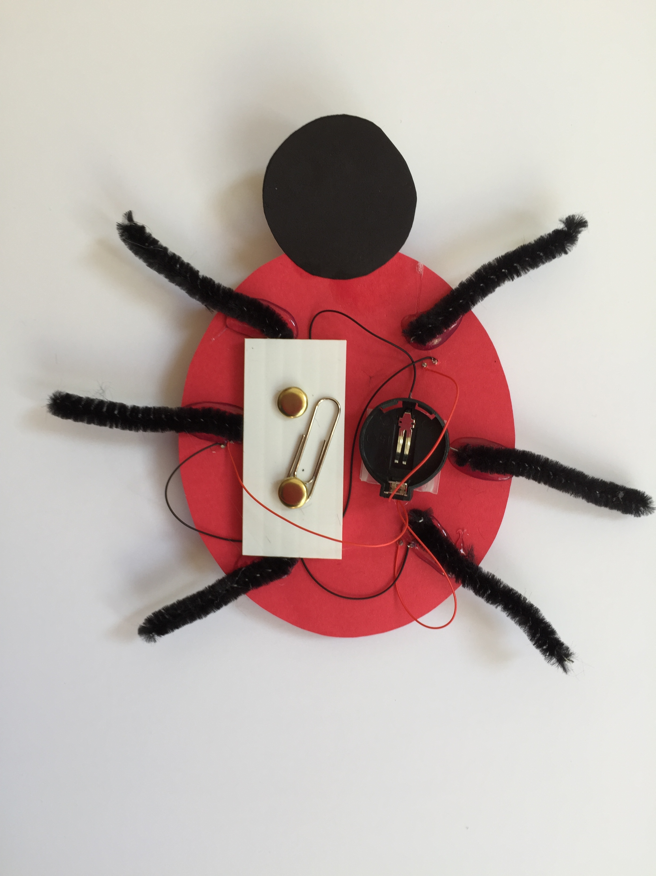

1. Hot glue the legs to the underside of the ladybug body, evenly distributing three legs on each side.
2. Bend the legs so that the ladybug stands up.



1. Using the straight pin, punch two holes, one behind each eye.
2. Thread the remaining black wire through the holes to form antennae. Hot glue the antennae into place on the underside of the head.
3. Curl the antennae ends.
4. Install the battery so that the + side is facing up.
5. Close the paperclip switch and VOILA!

